**Techolution Assessment**

1. **Create a new VPC on us-west-2 by leveraging Terraform and create 2 subnets as below:**

**(a) Public Subnet**

**(b) Private Subnet**

**Launch one instance in each of the subnets above and demonstrate ssh from your local to the private instance.**

Pushed the terraform script used for creating VPC, two subnets (public & private) and two ec2-instances in each subnet to the github repository with commit message “[Terraform Script for VPC & EC2 Instance](https://github.com/Nikhilraja/Techolutions/commit/0dbcc0870265e2a2b6b93ed0f321e14d46af5b4c)”.

Below are the screenshots of the VPC, Subnets and EC2 Instances created using terraform script.

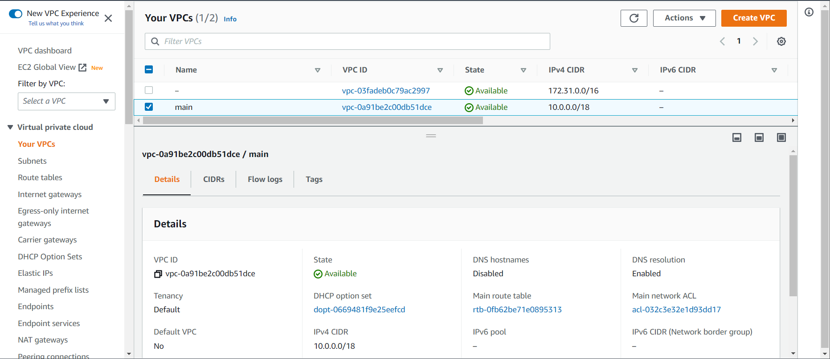

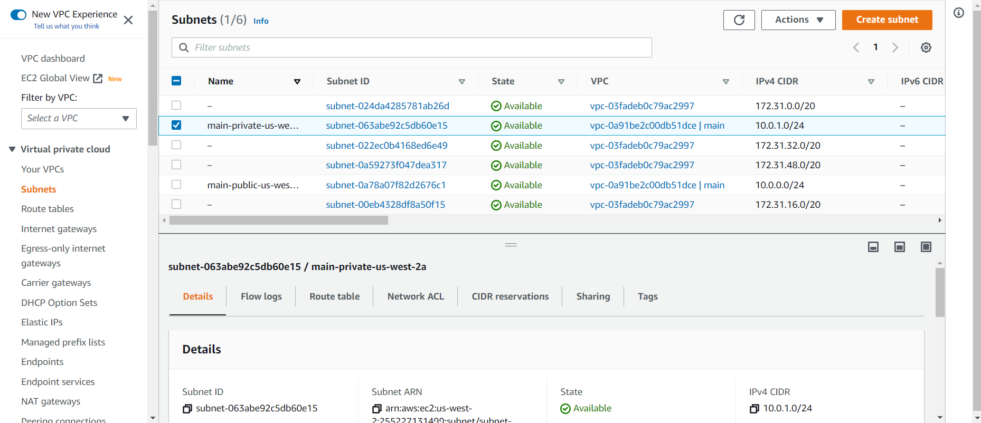

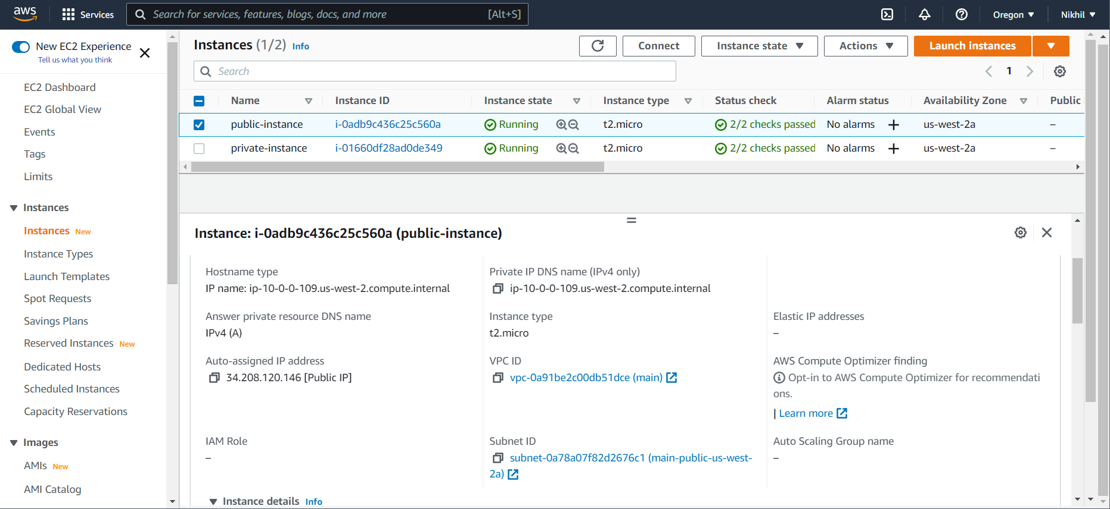

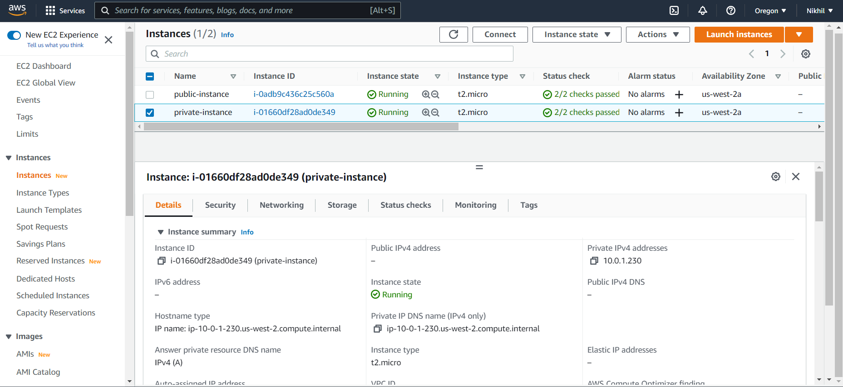

Now, below are the IP Addresses allocated for Public and Private Instances

Public Instance:

* Public IP : 34.208.120.146
* Private IP: 10.0.0.109

Private Instance:

* Private IP: 10.0.1.230

Below is the screenshot which is connected to Instance created in Private Subnet from my local.

For this, initially I logged into Instance in Public Subnet over internet and created pem file contents same to the key pair given at the time of instance creation. Then logged into instance in private subnet from instance in public subnet.

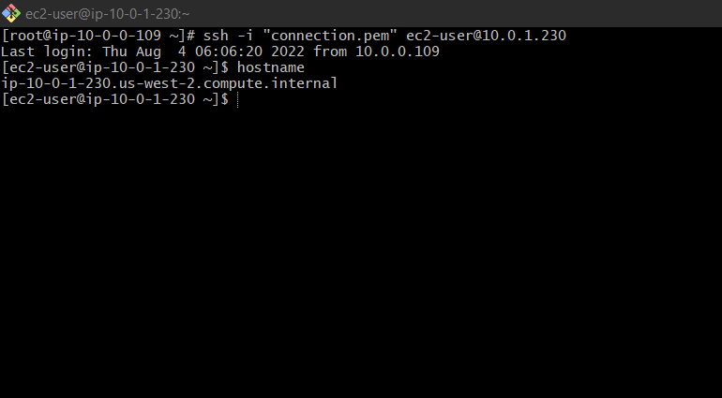

**2. Configure LoadBancer for EC2**

Created a new load balancer in AWS and routed the traffic to the target group. The target group consists of two ec2 instances which we created as part of 1st question. Below are the screenshots.

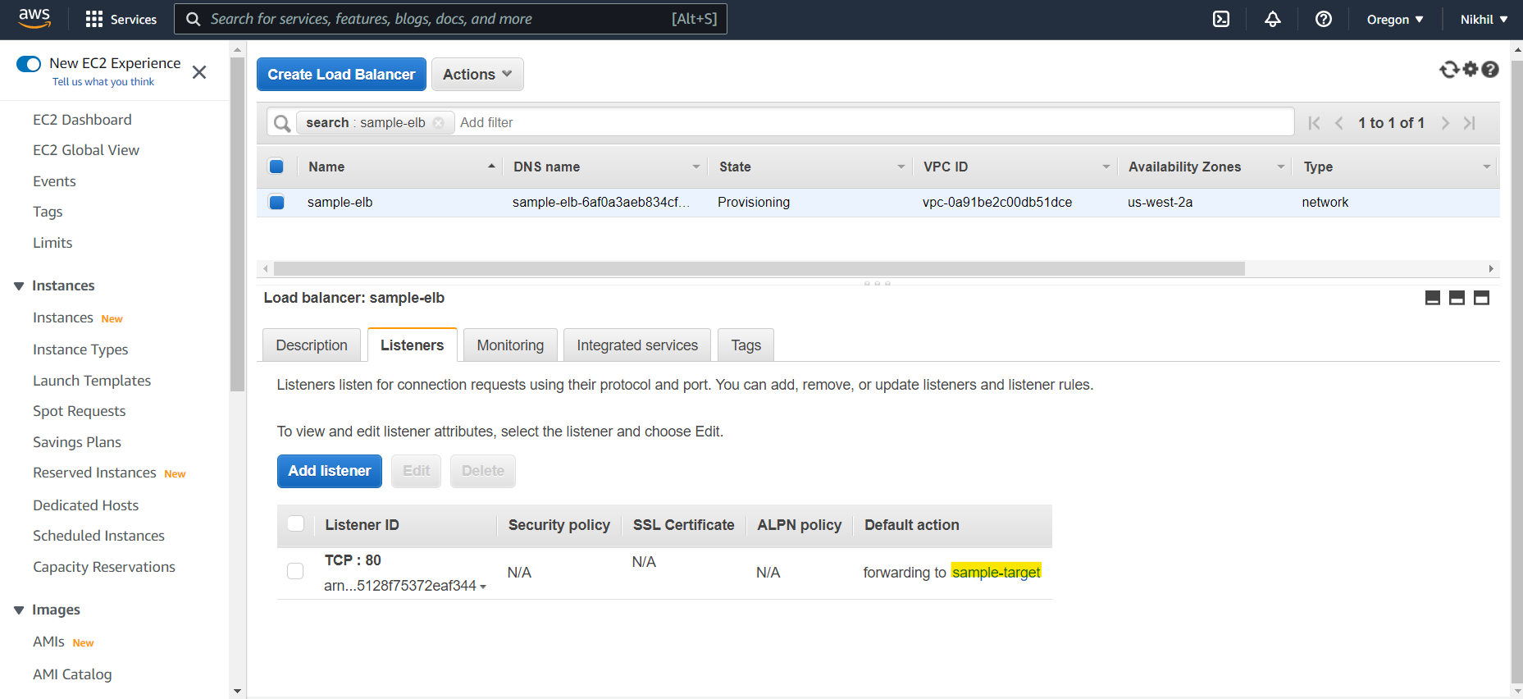

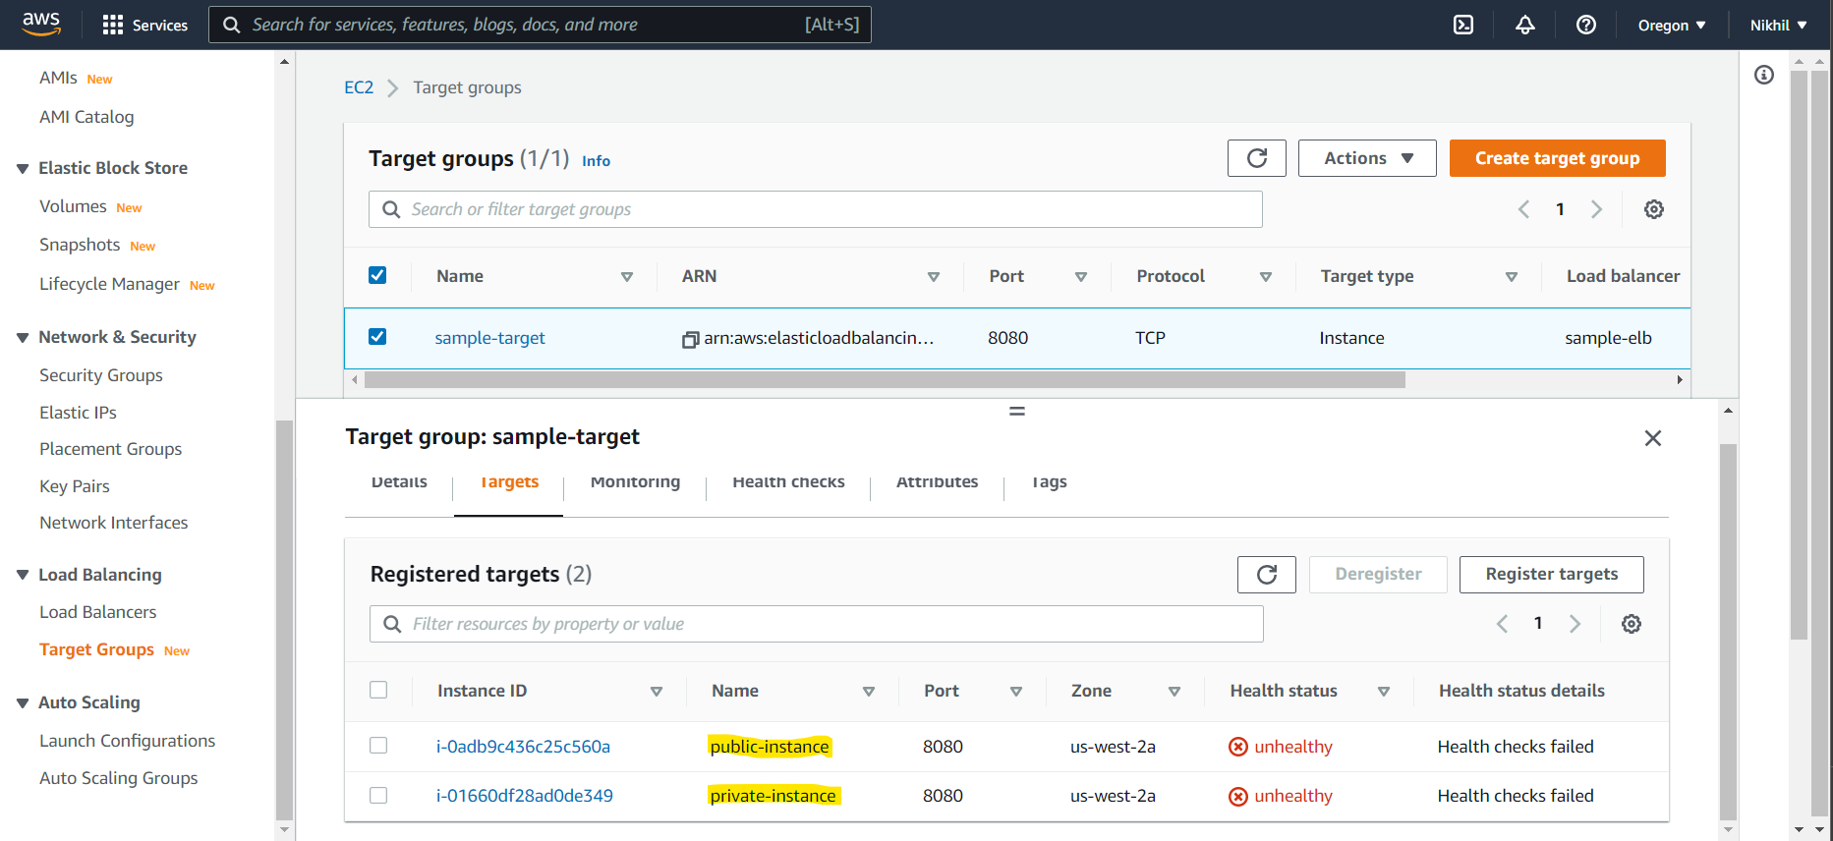

**3. Deploy any sample application in the ECS cluster which should be accessible through Load Balancer**

Created a sample Docker Image and pushed to the Docker Hub registry and using that image in ECS cluster. Below is the ECS created along with Image details.

Link for Docker Image: <https://hub.docker.com/repository/docker/nikhilraja/maven-web-project>

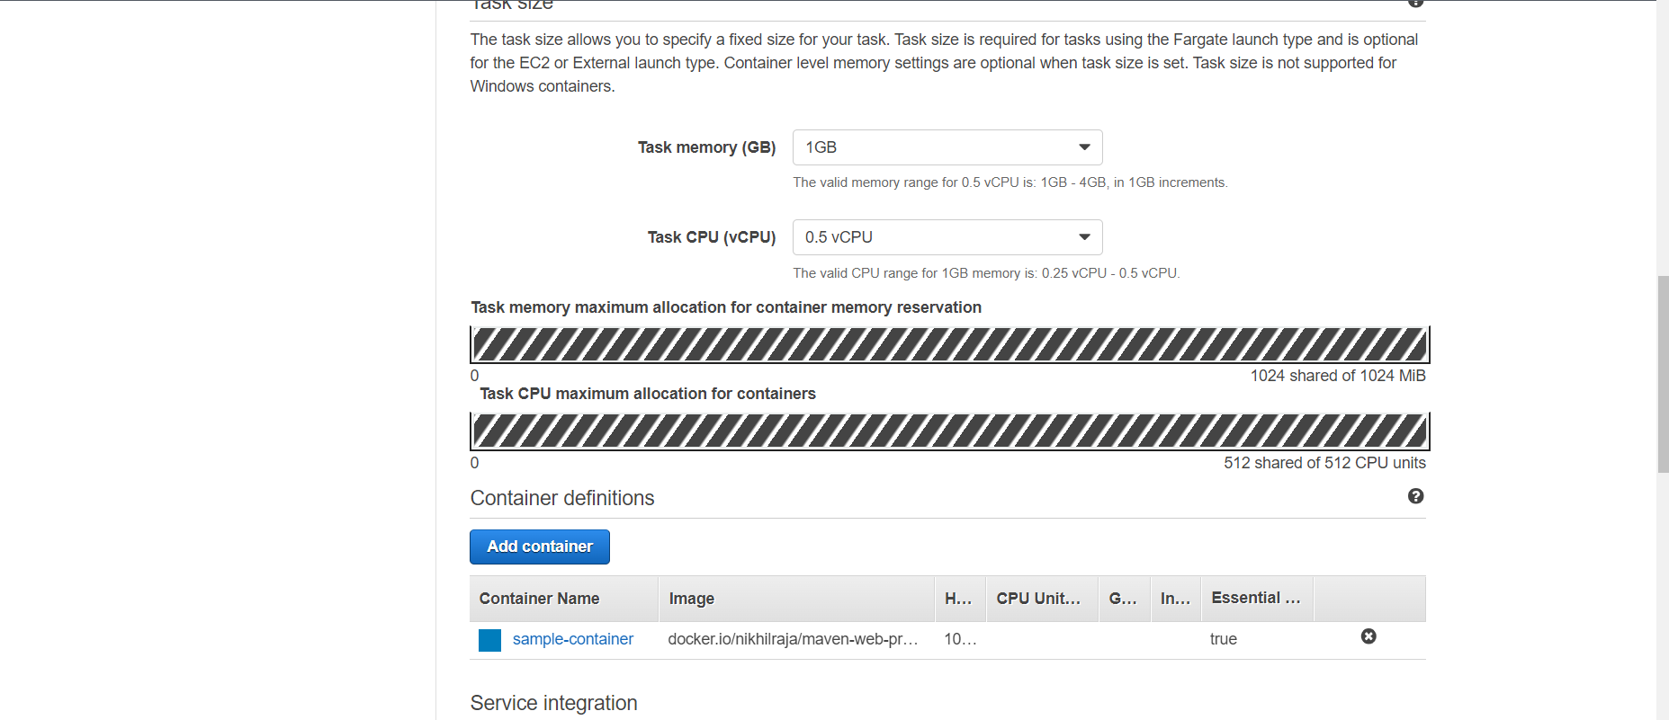

Created the required ECS cluster and Task Definitions and the required application is deployed in the Private Subnet of the VPC created as part of 1st question.

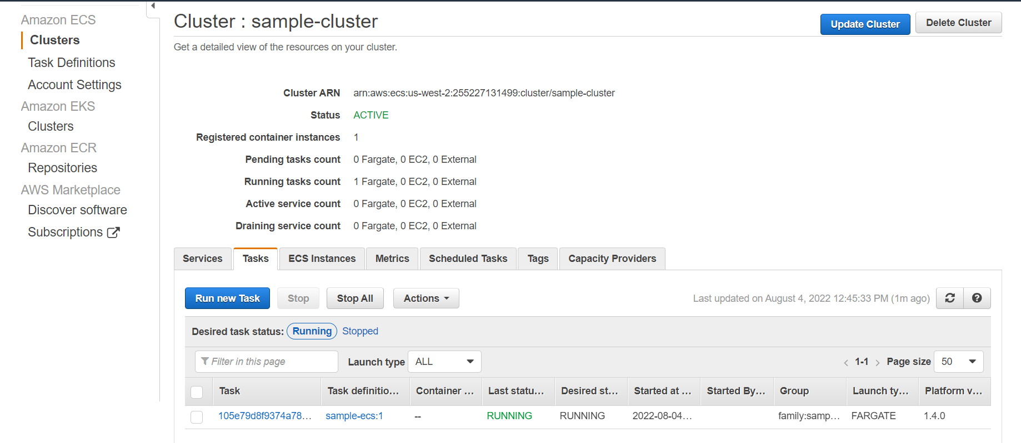

**4. Create Automation Script for 1 or 2 points using your best judgment.**

Pushed the required automation scripts into GitHub repository.